My.Point.Edu Single Sign On (SSO)
My.point.edu is a single sign on website portal that allows users to access Point University’s web applications with one user name and password. Within the portal, users can access email, the Intranet, PointLearning, CampusBubble, and other applications.
Go to http://my.point.edu
Type in your computer/email user name and password and click Sign in.
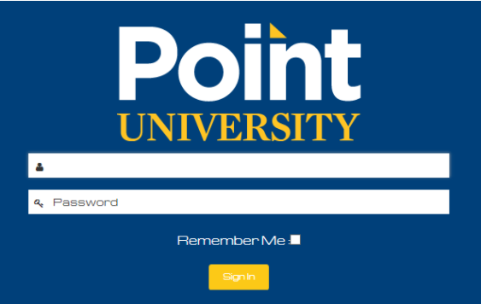
Once you are logged in you will see your applications. Simply click on the application that you want to open and you will be automatically logged in.
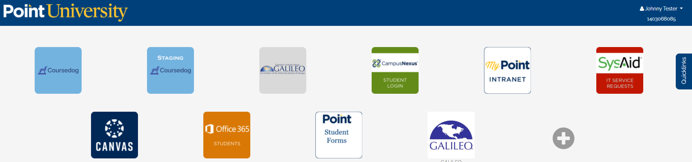

In the upper right corner, you can click on your username to email IT Support, logout, or view your profile.
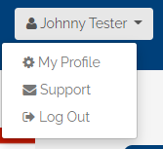
Under your name, the number displayed is your student ID number. You will need this number when calling into request a password reset, or access to any of your personal information. You will want to keep this number secure.
On the right side of the screen, you will see a tab called Quicklinks. Clicking on the Quicklinks tab will pull out a menu with several online library resources.
