MULTI FACTOR AUTHENTICATION
On a computer or other device, log into your Office 365 online account by going to https://my.point.edu and logging in. Click on the Office 365 button. You should be prompted to verify your identity with the Microsoft Authenticator app. Click next and download the app to your mobile device.
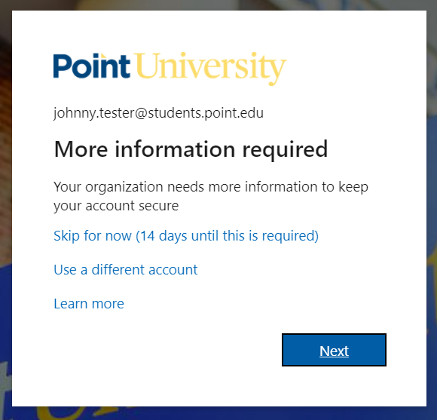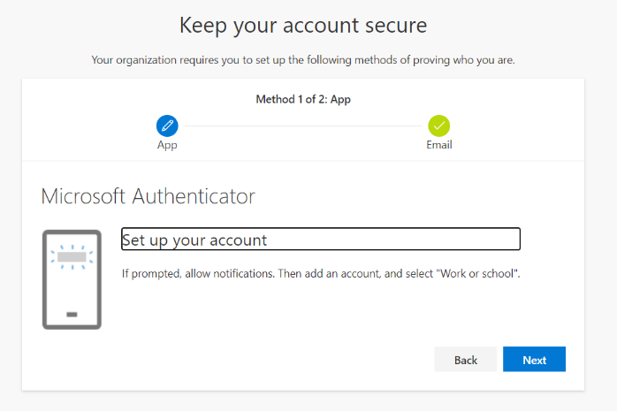
Open the app store on your Apple or Android device, and search for Microsoft Authenticator. Install the app.
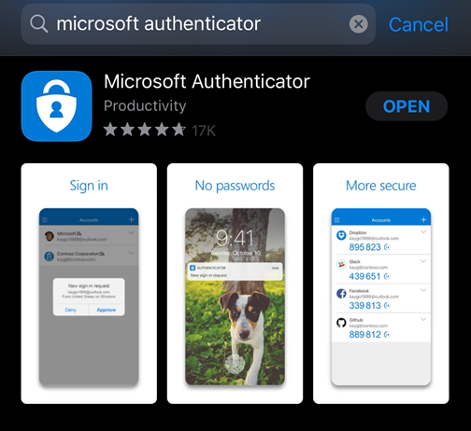

Open the Authenticator app that you just installed, and click the + in the upper right corner to add an account, or click "Add your account".
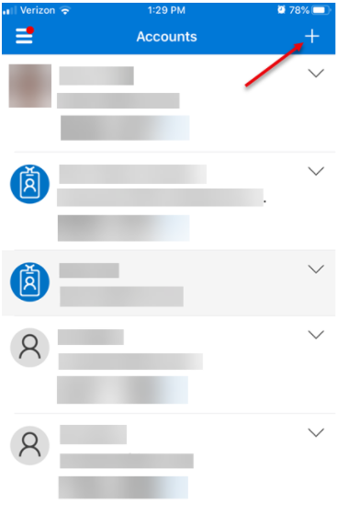
Select Work or School account. When you are prompted to sign in or scan QR code, choose scan QR code.
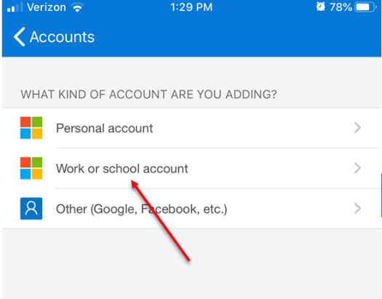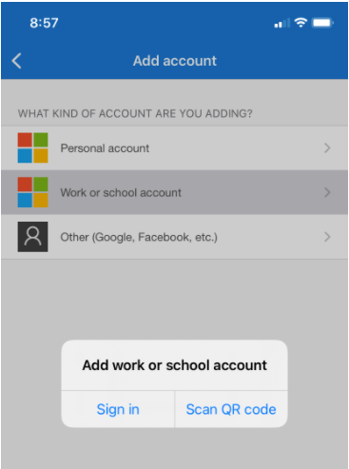
Point your phone's camera at the QR code on your computer to scan it.
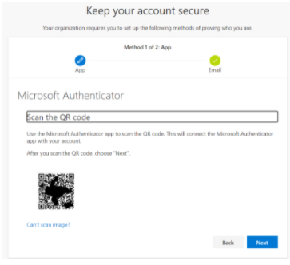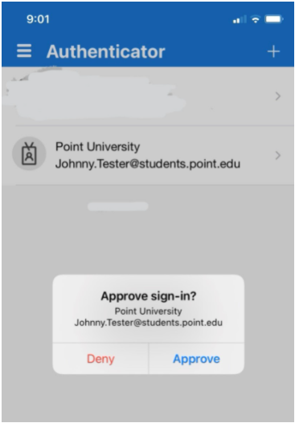
After scanning the QR code, click next on your computer and you should get a message on your phone to approve the sign in. Click Approve.

After clicking approve on your phone, you will have access to Office 365. Any time you log into a new device, you will need to approve the log in on your phone. If you get a request to approve a login that you did not start, click Deny.

