# **How to Locate a Book**

The library has access to both print and electronic books (ebooks). The majority of the library is comprised of books that are electronic. The library has access to over 750,000 electronic books and over 13,000 print volumes.

## **Electronic Books**

You can access electronic books from any computer or mobile device by logging into MYPOINT from Point.edu. Enter your username and password. Once you sign in, click on the GALILEO tile, or you can click on any of the links at the bottom of the page in the Education Resources section, or you can access the GALILEO link in any Canvas course. Once you are at the GALILEO page, enter your search terms in the search box in the middle of the page.

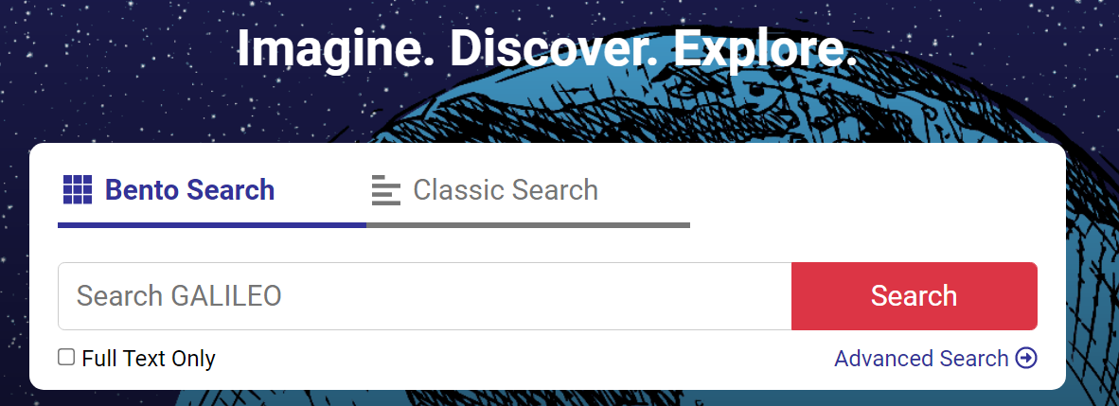

You have two ways of searching either by using *Bento Search* or *Classic Search*. *Bento Search* is the default search style and all of your search results will be shown in bento-style boxes: Scholarly Articles, eBooks, etc. *Classic Search* puts all results together by relevancy. To refine a Classic Search the following steps will be helpful once your search results appear.

* In the **[ Refine Results ]** column to the left, you will see a section heading **[ Limit by Type ]**.
* Click on **[ Show More ]** at the bottom of that section heading.
* You will select **[ Books ]** and **[ eBooks ]** and then click on **[ Update ]**.
* Your results will now list all books that can be accessed electronically.

## **Print Books**

To search the library catalog, visit: **https://elibrary.point.edu**

* The first search box “Library catalog” will allow you to search the print books in the collection.
* Your results will show books that are available for checkout.
* You will need your Skyhawk Card to checkout materials.

If at any time you need assistance locating a resource, please contact the library at: library@point.edu